**Basavarajeswari group of institutions**

# Ballari Institute of Technology & Management

**AUTONOMOUS INSTITUTE UNDER VISVESVARAYA TECHNOLOGICAL UNIVERSITY JNANASANGAMA,**

**BELAGAVI 590018**

**INTERNSHIP**

**Report On**

**Athlete media appearance scheduler**

Submitted in partial fulfillment of the requirements for the award of degree of

# Bachelor of Engineering In

## COMPUTER SCIENCE AND ENGINEERING

### Submitted by

### SHRIDEVI:3BR22CS158

### Internship Carried Out

### By

**EZ TRAININGS & TECHNOLOGIES PVT.LTD**

**HYDERABAD**

**Internal Guide External Guide**

**Mrs. MADHURI A Mr. BALAJI SRINIVASAN**

**Assistant Professor ,CSE Sr. Faculty**

**Ms. SAMEENA YASMEEN**

**Supervisor ,CSE**

#### BALLARI INSTITUTE OF TECHNOLOGY & MANAGEMENT

NACC Accredited Institution*

**(RecognizedbyGovt.ofKarnataka,approvedbyAICTE,NewDelhi&AffiliatedtoVisvesvarayaTechnologicalUniversity,Belagavi)**

**"JnanaGangotri"Campus,No.873/2,Ballari-HospetRoad,Allipur,Ballar1-583104(Karnataka)(India)Ph:08392–237100/237190,Fax:08392–237197**2023-2024

**Basavarajeswari group of institutions**

## BALLARI INSTITUTE OF TECHNOLOGY & MANAGEMENT

**Autonomous institute under VISVESVARAYA TECHNOLOGICAL UNIVERSITY JNANASANGAMA,**

**BELAGAVI 590018**

NACC Accredited Institution*

**(RecognizedbyGovt.ofKarnataka,approvedbyAICTE,NewDelhi&AffiliatedtoVisvesvaraya Technological University, Belagavi)**

**"JnanaGangotri"Campus,No.873/2,Ballari-HospetRoad,Allipur,**

**Ballar1-583104(Karnataka)(India) Ph:08392–237100/237190,Fax:08392–237197**

## DEPARTMENT OF COMPUTER SCIENCE AND ENGINEERING

**CERTIFICATE**

This is to certify that the Internship entitled **“ Athelete media appearance scheduler ”** has been successfully completed by **shridevi** bearing USN **3BR22CS158** bearing USN bearing USN bearing USN a bonafide student of Ballari Institute of Technology and Management, Ballari. For the partial fulfillment of the requirements for the **Bachelor’s Degree in Computer Science and Engineering** of the VISVESVARAYA TECHNOLOGICAL UNIVERSITY, Belagavi during the academic year 2023-2024.

#### Signature of Internship

#### Co-ordinators

**Signature of HOD**

**Mrs. MADHURI A Dr. R N KULKARNI**

**Assistant Professor ,CSE Professor & HOD(CSE)**

&

**Ms. SAMEENA YASMEEN**

**Supervisor ,CSE**

**DECLARATION**

I, **Sneha Devale & Tejashwini VR & Yashoda & Shridevi,** second year student of Computer Science and Engineering, Ballari Institute of Technology, Ballari, declare that Internship entitled **ATHELETE MEDIA APPEARANCE SCHEDULER** is a part of Internship Training successfully carried out by **EZ TECHNOLOGIES & TRAININGS PVT.LTD, Hyderabad** at “**BITM, BALLARI”.** This report is submitted in partial fulfillment of the requirements for the award of the degree, Bachelor of Engineering in Computer Science and Engineering of the Visvesvaraya Technological University, Belagavi.

**Date : 4-5-2024 Signature of the Student**

**Place : Ballari**

**ACKNOWLEDGEMENT**

The satisfactions that a company the successful completion of my internship on “ Athelete media appearance scheduler ” would be incomplete without the mention of people who made it possible, whose noble gesture, affection, guidance ,encouragement and support crowned my efforts with success. It is my privilege to express my gratitude and respect to all those who inspired me in the completion of my internship.

I am grateful to my respective coordinators “**Mrs.Madhuri A(Asst.prof,CSE) and Ms.Sameena Yasmeen (Supervisor,CSE)**” for their noble gesture ,support co-ordination and valuable suggestions given to me in the completion of Internship.

I also thank **Dr. R N Kulkarni,** HOD , Department of **Computer Science and Engineering** for extending all his valuable support and encouragement.

**Table of Contents**

|  |  |  |
| --- | --- | --- |
| **Chapter No.** | **Chapter Name** | **Page No.** |
| **1** | **Company Profile** | **1** |
| **2** | **Day to day activity(student diary extract)** | **2** |
| **3** | **Abstract** | **3-4** |
| **4** | **Introduction of the project** | **5** |
| **5** | **Description** | **6-7** |
| **6** | **Flowchart** | **8** |
| **7** | **Output** | **9** |
| **8** | **Conclusion** | **10** |
| **9** | **References** | **11** |

**COMPANY PROFILE**

**Company Name : EZ Trainings and Technologies Pvt. Ltd.**

**Introduction:**

EZ Trainings and Technologies Pvt. Ltd. is a dynamic and innovative organization dedicated to

providing comprehensive training solutions and expert development services. Established with

a vision to bridge the gap between academic learning and industry requirements, we specialize

in college trainings for students, focusing on preparing them for successful placements.

Additionally, we excel in undertaking development projects, leveraging cutting-edge

technologies to bring ideas to life.

**Mission:**

Our mission is to empower the next generation of professionals by imparting relevant skills and

knowledge through specialized training programs. We strive to be a catalyst in the career growth

of students and contribute to the technological advancement of businesses through our development

projects.

**College Trainings:**

* Tailored training programs designed to enhance the employability of students.

* Industry-aligned curriculum covering technical and soft skills.

* Placement assistance and career guidance.

**Development Projects:**

* End-to-end development services, from ideation to execution.

* Expertise in diverse technologies and frameworks.

* Custom solutions to meet specific business needs.

Locations: Hyderabad | Delhi NCR

At EZ Trainings and Technologies Pvt. Ltd., we believe in transforming potential into excellence

**DAY TO DAY ACTIVITIES**

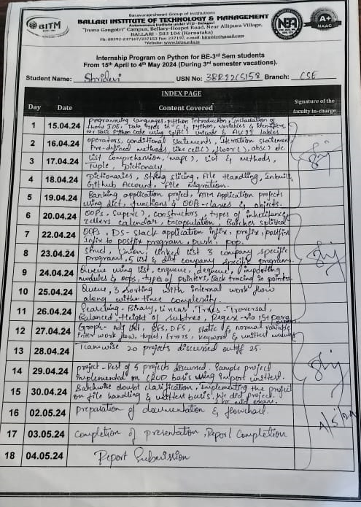

**ABSTRACT**

The main idea of this project is to create a simple media appearance scheduler for athletes. The program defines three classes:

1. **Athlete**: Represents an athlete with attributes like athlete ID, name, and sport.
2. **MediaScheduler:** Represents a media appearance schedule with attributes like schedule ID, athlete ID, date, and media outlet.
3. **Scheduler**: Manages media appearance schedules and provides methods to create, read, update, and delete schedules, as well as to organize media appearances for a specific athlete.
4. **Athlete Class:** This class represents an athlete and has the following attributes:

* **athlete_id**: An integer representing the unique ID of the athlete.
* **name**: A string representing the name of the athlete.
* **sport:** A string representing the sport in which the athlete participates.

1. **MediaScheduler Class:** This class represents a media appearance schedule and has the following attributes:

* **schedule_id**: An integer representing the unique ID of the schedule.
* **athlete_id:** An integer representing the ID of the athlete associated with the schedule.
* **date:** A string representing the date of the media appearance.
* **media_outlet:** A string representing the media outlet for the appearance.

1. **Scheduler Class:** This class manages the media appearance schedules and provides methods to interact with them. It has the following attributes and methods:

* **schedules**: A list to store instances of MediaScheduler class representing all the schedules.
* **media_outlets**: A dictionary to store media outlets and their corresponding schedules.
* **athletes:** A list to store instances of the Athlete class representing all the athletes.
* **create_media_schedule(schedule_id, athlete_id, date, media_outlet):** Method to create a new media appearance schedule and add it to the list of schedules.
* **read_media_schedule(schedule_id):** Method to retrieve a media appearance schedule based on its ID.
* **update_media_schedule(schedule_id, updated_data**): Method to update the date or media outlet of a media appearance schedule.
* **delete_media_schedule(schedule_id):** Method to delete a media appearance schedule.
* **organize_media_appearances(athlete_id):** Method to retrieve all media appearances for a specific athlete.

1. **TestScheduler Class:** This class contains unit tests to verify the functionality of the Scheduler class. It sets up a Scheduler instance with sample data and tests various methods of the Scheduler class.

Overall, the project demonstrates object-oriented programming concepts in Python, such as classes, objects, methods, and inheritance, to create a simple media appearance scheduler for athletes.

INTRODUCTION OF THE PROJECT

This program is a simple implementation of a media appearance scheduler for athletes. It uses classes to represent athletes and their media schedules. The Scheduler class manages these schedules and provides methods for creating, reading, updating, and deleting them. It also includes a method to organize media appearances for a specific athlete.

The TestScheduler class contains unit tests to verify the functionality of the Scheduler class. These tests ensure that the scheduler behaves as expected when creating, reading, updating, and deleting media schedules.

**Problem Statement:**

•The challenge of efficiently managing media appearances for athletes is a complex

one, requiring careful coordination and organization.

•Without a centralized system, scheduling conflicts and communication gaps can

arise, leading to missed opportunities and disorganized appearances.

**Objective:**

•To develop a Proof of Concept (POC) for an Athlete Media Appearance Scheduler

using object-oriented programming (OOP) and data structures and algorithms (DSA)

principles in Python.

The POC aims to demonstrate the feasibility and functionality of such a system, focusing on

CRUD operations for media schedules, organizing appearances for athletes, and managing

relationships with media outlets. This project aims to develop a Proof-of-Concept (POC)

application in Python to streamline the scheduling of media appearances for athletes. It

leverages the power of Object-Oriented Programming (OOP) and Data Structures and

Algorithms (DSA) principles.

**MODULE DISCRIPTION**

* **The Athlete class :** it provides a blueprint for creating objects that represent athletes.

Each instance of this class encapsulates information about a specific athlete,

including their unique identifier (athlete_id), name (name), and the sport (sport)

they participate in.

* **The MediaSchedule class :** is designed to manage and organize media schedules

associated with individual athletes within a software system. It encapsulates

information related to scheduled media appearances or events for athletes,

facilitating efficient tracking and management of media engagements.

* **The Scheduler class:** serves as a central component for managing scheduling

operations within a software system. It provides functionality for organizing various

schedules, including media engagements, events, or appointments. Additionally, it

facilitates the coordination of schedules for athletes and media outlets.

* **The TestScheduler class:** is a vital component in software testing environments. It's

designed to facilitate the scheduling, organization, and execution of tests within a

testing framework or environment. This class serves as a central hub for managing

various test cases, ensuring they run efficiently, and collecting results for analysis.

* **create_media_schedule(schedule_id, athlete_id, date, media_outlet):** Creates a

new media schedule entry with the provided details and adds it to the list of

schedules.

* **read_media_schedule(schedule_id):** Retrieves the media schedule entry

corresponding to the given schedule ID.

* **update_media_schedule(schedule_id, updated_data):** Updates the details of the

media schedule entry identified by the given schedule ID with the provided

updated data.

* **delete_media_schedule(schedule_id):** Deletes the media schedule entry

associated with the given schedule ID from the list of schedule

* **test_delete_media_schedule(self):** This method tests the delete_media_schedule

method of the Scheduler class. It checks whether the method correctly removes a

media schedule entry from the scheduler's list of schedules based on the provided

schedule ID.

* **test_organize_media_appearances(self):** This method tests the

organize_media_appearances method of the Scheduler class. It verifies whether the

method correctly retrieves all media appearances scheduled for a specific athlete

based on the provided athlete ID.

* **unittest.main()** is a method provided by the unittest module, which is Python's built-in testing framework.The verbosity parameter controls the amount of detail displayed in

the test results output.

* It accepts three levels of verbosity:
* 0: Quiet mode, only displays the total number of tests and errors.
* 1: Default mode, displays a dot for each successful test and F for each failed test, along with the total counts.
* 2: Verbose mode, displays the name of each test and its result, including successful

tests.In your script, unittest.main(verbosity=0) is set to quiet mode (verbosity=0),

meaning it will only show the total number of tests run and any errors encountered,

without detailed test-by-test output.

**FLOW CHART**

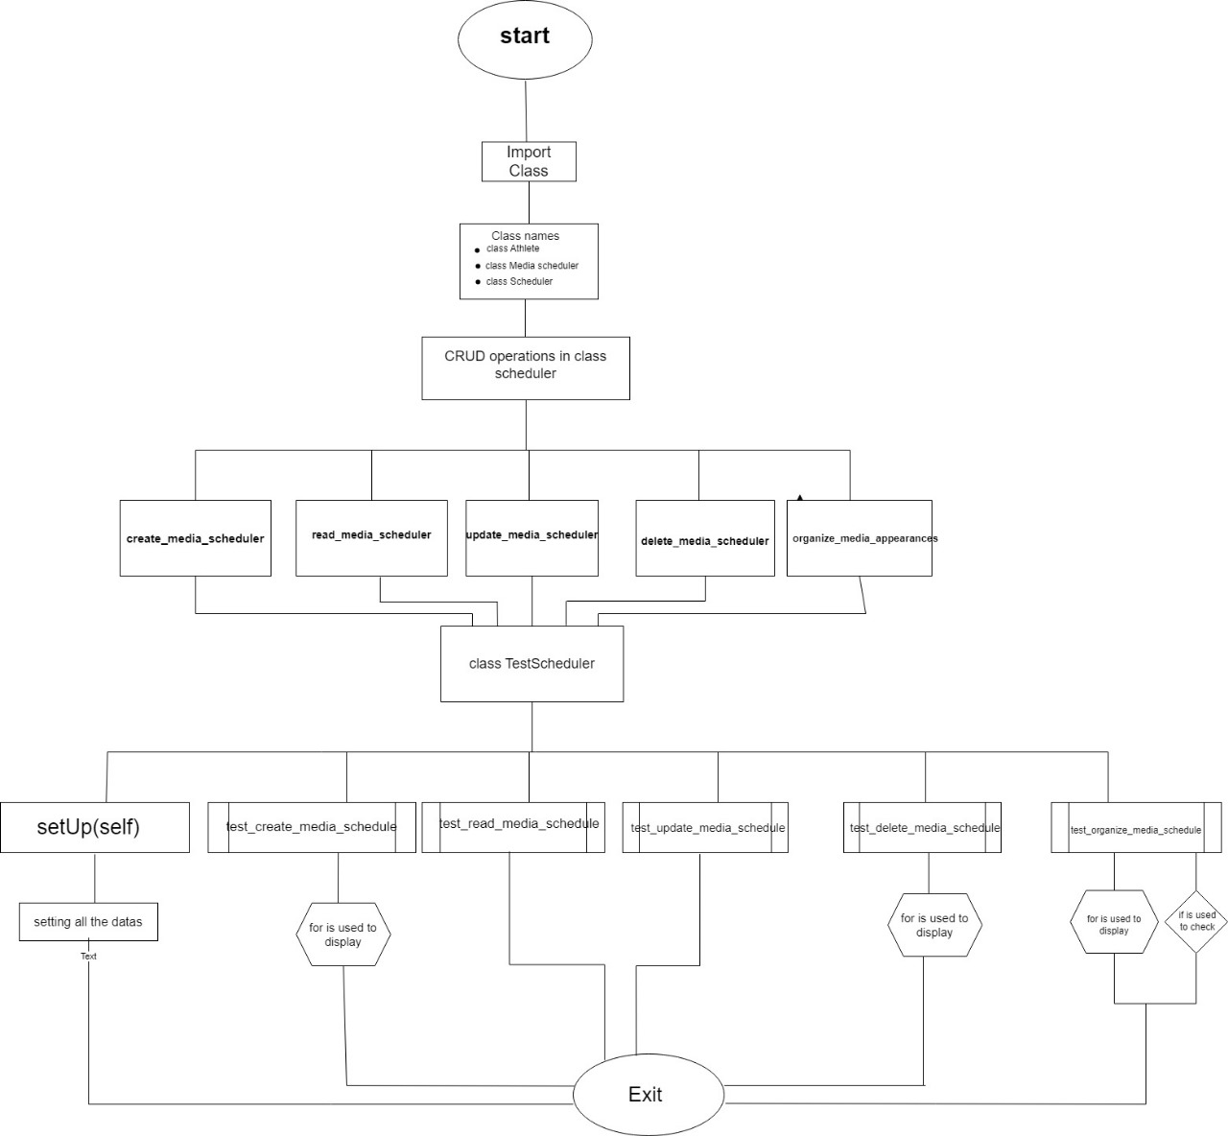

**OUTPUT**

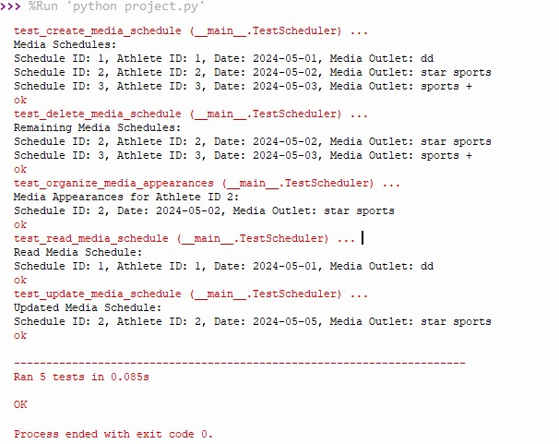

**CONCLUSION**

The code defines classes for managing media schedules for athletes. Here's a brief conclusion for the code:

* The **Athlete** class represents an athlete with attributes such as athlete_id, name, and sport.
* The **MediaScheduler** class represents a media schedule with attributes such as schedule_id, athlete_id, date, and media_outlet.
* The Scheduler class manages media schedules and athletes. It has methods to create, read, update, and delete media schedules, as well as organize media appearances for a specific athlete.
* The **TestScheduler** class contains unit tests for the methods in the Scheduler class to ensure they work as expected.

Overall, the code provides a basic framework for managing media schedules for athletes, including functionality for CRUD operations and organizing media appearances

**REFERENCE**

* [**https://chat.openai.com/c/40a9f7d5-acc0-49ed-8614-33b269d6b2c0**](https://chat.openai.com/c/40a9f7d5-acc0-49ed-8614-33b269d6b2c0)
* **Google, MS word, google colab**
* [**https://apphttps://app.diagrams.net/.diagrams.net/**](https://apphttps://app.diagrams.net/.diagrams.net/)
* **Thonny**

[GITHUB ACCOUNT :](https://github.com/shridevi-23)

* [**https://github.com/shridevi-23**](https://github.com/shridevi-23)
* [**https://github.com/tejashwinivr/BITM**](https://github.com/tejashwinivr/BITM)
* [**https://github.com/Snehadevale**](https://github.com/Snehadevale)
* [**https://github.com/yashodhakampli**](https://github.com/yashodhakampli)